

PROJECT
ON
College Management System

SUBMITTED IN PARTIAL FULFILLMENT OF THE REQUIREMENTS
FOR THE DEGREE IN
BACHELOR OF COMPUTER APPLICATIONS (BCA)

SUBMITTED TO: | SUBMITTED BY:
Name: Chandigarh University | Name: Balteg Singh & Simran
Designation: _____________________ | UID: 25BCA10463 & 25BCA10384
Department of Computer Applications | Section: 25BCA6 A

DEPARTMENT OF COMPUTER APPLICATIONS
CHANDIGARH UNIVERSITY
GHARUAN, MOHALI (PUNJAB)

Abstract
The College Management System presented in this report is an integrated relational database solution designed to streamline academic administration across six core functional areas: Student Management, Faculty Management, Attendance, Examination, Fee Management, and Course Management. The project models the day-to-day data flows of a typical college into a normalized schema of eight primary entities connected by clearly defined primary and foreign key relationships, enabling consistent storage, fast retrieval, and reliable reporting.
The design follows the principles of the relational model proposed by Codd and applies step-by-step normalization from the Unnormalized Form (UNF) through First, Second, and Third Normal Forms (1NF, 2NF, 3NF) to eliminate redundancy and update anomalies. The SQL implementation covers Data Definition Language (DDL) statements that create the schema with appropriate constraints, Data Manipulation Language (DML) statements that populate tables with realistic sample records, Data Query Language (DQL) statements that demonstrate reporting scenarios, and stored procedures and triggers that encapsulate business rules such as automatic fee due flagging and attendance deficiency alerts.
The report analyses the system in terms of advantages (centralized data, integrity enforcement, automated reporting, scalability) and limitations (single-tenant scope, absence of a built-in authentication layer, dependence on manual backup procedures). It also outlines a future scope that includes a web-based front end, biometric attendance, notifications, library and hostel extensions, analytics dashboards, and cloud deployment. The deliverable demonstrates that a well-designed relational database forms a robust foundation for a future full-scale college Enterprise Resource Planning (ERP) system.
Keywords: College Management System; DBMS; Relational Database; Normalization; ER Diagram; SQL; Stored Procedures; Triggers; Academic Administration
Table of Contents
Abstract
Abstract 1
Chapter 1 Introduction 2
1.1 Background 2
1.2 Objectives 2
1.3 Scope and Users 3
Chapter 2 System Features and Modules 4
2.1 Student Management 4
2.2 Faculty Management 5
2.3 Attendance Management 5
2.4 Examination Management 6
2.5 Fee Management 6
2.6 Course Management 7
Chapter 3 Advantages and Benefits 7
3.1 One Source of Truth 7
3.2 Data Integrity through Constraints 8
3.3 Fast Retrieval and Reporting 8
3.4 Automated Business Rules 8
3.5 Reduced Paperwork and Manual Errors 8
3.6 Scalability and Extensibility 9
3.7 Foundation for a Full ERP 9
Chapter 4 Disadvantages and Limitations 9
4.1 No Built-in Authentication Layer 10
4.2 Single-Tenant Design 10
4.3 No User Interface in This Scope 10
4.4 Manual Backup and Recovery 10
4.5 Concurrency Contention under Heavy Load 11
4.6 Dependence on SQL Knowledge for Ad-hoc Reports 11
4.7 Normalization Trade-offs 11
Chapter 5 Database Design and ER Diagram 11
5.1 Entity-Relationship Overview 12
5.2 ER Diagram 12
5.3 Schema Overview 13
Chapter 6 Normalization 13
6.1 Unnormalized Form (UNF) 13
6.2 First Normal Form (1NF) 14
6.3 Second Normal Form (2NF) 14
6.4 Third Normal Form (3NF) 15
Chapter 7 SQL Implementation — Schema (DDL) 16
7.1 Database Creation and Drop Order 16
7.2 Department, Faculty, and Course Tables 17
7.3 Student Table 17
7.4 Enrollment Table (Junction for Student–Course Many-to-Many) 17
7.5 Attendance Table 18
7.6 Exam and Marks Tables 18
7.7 FeePayment Table 19
7.8 Audit Table for Trigger Use 19
Chapter 8 SQL Implementation — Sample Data (DML) 19
8.1 Departments, Faculty, and Courses 20
8.2 Students, Enrollment, and Attendance 20
8.3 Exams, Marks, and Fee Payments 20
Chapter 9 SQL Queries (DQL) — Reporting Scenarios 21
9.1 Query 1 — List All Students with Their Department 21
9.2 Query 2 — Count Students per Course 22
9.3 Query 3 — Attendance Percentage per Student per Course 22
9.4 Query 4 — Students with Outstanding Fee Dues 23
9.5 Query 5 — Top Three Scorers per Exam 23
9.6 Query 6 — Faculty Workload (Number of Courses per Faculty) 24
9.7 Query 7 — Students Whose Attendance is Below 75 Percent 24
9.8 Query 8 — Students Scoring Above the Class Average 25
Chapter 10 Stored Procedures and Triggers 25
10.1 Stored Procedure: sp_RegisterStudent 25
10.2 Stored Procedure: sp_MarkAttendance 26
10.3 Trigger: trg_FeePaymentAudit 26
10.4 Trigger: trg_PreventMarkDelete 27
Chapter 11 System Analysis 27
11.1 Performance Analysis 28
11.2 Security Considerations 28
11.3 Data Integrity Review 28
11.4 Backup and Recovery 29
Chapter 12 Future Scope 29
12.1 Web and Mobile Front End 29
12.2 Biometric Attendance Integration 30
12.3 Email and SMS Notifications 30
12.4 Library and Hostel Management Extensions 30
12.5 Analytics Dashboard 30
12.6 Role-Based Authentication with JWT Sessions 31
12.7 Cloud Deployment with Automated Backups 31
12.8 AI-Based Result Prediction and Early Warning 31
Chapter 13 Conclusion 31
References 32
Appendix A Sample Data Snapshots 34
A.1 Student Table — Sample Rows 34
A.2 Marks Table — Sample Rows 34

Note: This Table of Contents is generated via field codes. To refresh page numbers after editing, right-click the TOC and select "Update Field."
Chapter 1 Introduction
1.1 Background
A college is a busy place that handles many kinds of data every day. It admits new students at the start of every academic year, assigns faculty members to departments and courses, schedules classes, takes attendance for every lecture, conducts internal and semester examinations, and collects tuition and other fees from students. Each of these activities produces records that the college must keep safely and use for years — a student admitted in 2021 will keep producing attendance, marks, and fee records until 2024 or later.
When this data is kept in paper registers or in scattered spreadsheets, three problems appear. First, the same data is typed many times in many places — a student's name and contact details might appear in the admission register, the attendance register, the marks sheet, and the fee book, so a change of phone number has to be made in four places, and any one of them can be missed. Second, reports take a long time to compile — to find out which students have attendance below 75 percent, someone has to flip through every attendance register and add up the totals by hand, which can take hours for a single class. Third, data gets lost or reported wrongly because registers are misplaced, handwriting is unreadable, or totals are added up incorrectly.
A Database Management System (DBMS) solves these problems by keeping all data in one place where every authorized user sees the same correct information. The relational model, proposed by E. F. Codd in 1970, organizes data into tables (called relations) connected by primary and foreign keys. Each table holds one kind of thing — students in one table, faculty in another, courses in a third — and the keys let the DBMS connect them on demand. Updates flow consistently because the data lives in only one place, and queries can be written in a single declarative language called SQL (Structured Query Language) that asks for what you want without telling the system how to find it.
This project builds a College Management System using a relational database. It walks through the full database life cycle — identifying requirements, drawing an Entity-Relationship (ER) diagram, normalizing the design to remove redundancy, writing SQL CREATE TABLE statements with proper constraints, populating the tables with sample data, formulating reporting queries, and encapsulating business rules in stored procedures and triggers. The project is designed as a mini-project suitable for an undergraduate Database Management Systems course and demonstrates every concept that a student of databases needs to understand.
1.2 Objectives
The College Management System is built with seven concrete objectives in mind. Each objective is addressed by specific tables and SQL constructs later in the report, and each one solves a real problem that a college administrative office faces today.
• Centralize all college data. Keep student, faculty, course, attendance, examination, and fee data in one relational database so that every department sees the same single source of truth. No more maintaining the same student contact details in four different registers.
• Enforce data integrity. Use primary keys, foreign keys, UNIQUE, NOT NULL, and CHECK constraints at the database level so that wrong data is rejected before it is saved — regardless of which application is being used to enter the data.
• Support fast reporting. Pre-write SQL queries for the most common college reports — attendance percentages, fee dues, top scorers, faculty workload — so that what used to take hours of manual compilation can be produced in seconds by running a query.
• Automate business rules. Use stored procedures for repeated operations (registering a student, marking attendance) and triggers for audit and anomaly prevention (logging every fee payment, blocking marks deletion after publication).
• Demonstrate normalization. Apply step-by-step normalization from Unnormalized Form through 1NF, 2NF, and 3NF on a representative data set so that the design clearly avoids redundancy, insertion anomalies, and update anomalies.
• Provide a foundation for extension. Design the schema so that future modules (library, hostel, transport, alumni) can be added as new tables that reference existing ones — without modifying any existing table.
• Document the full design. Produce a complete project report covering features, advantages, disadvantages, ER diagram, normalization, SQL, procedures, triggers, system analysis, future scope, and references — so that any future developer can pick up the project and continue.
1.3 Scope and Users
The scope of this report is the database layer of the College Management System. It covers schema design, normalization, SQL implementation, sample queries, and procedural objects. It does NOT cover the user interface, the authentication front end, or the deployment infrastructure — these are described only at the level of recommendations in the Future Scope chapter. By keeping the scope focused on the database, the project demonstrates every important DBMS concept without being distracted by front-end concerns.
The primary user of the database is the college administrative office, which is responsible for maintaining student records, scheduling courses, taking attendance, conducting examinations, and collecting fees. The accounts office is a secondary user, recording fee payments and tracking dues. Faculty members are tertiary users — they view their assigned courses and record attendance for the classes they teach. Students themselves do not access the database directly in this version of the project, but they will become users in the future front-end extension, where they will view their own attendance and examination results.
The report itself is written for a management review audience — college decision-makers who need to understand what the system does, what benefits it brings, what its limitations are, and what the next investment steps should be. The language stays plain and the examples stay concrete so that a non-technical reader can follow the design without getting lost in database jargon. The SQL code blocks are kept short and well-commented so that a reader who does not know SQL can still understand what each statement achieves.
Chapter 2 System Features and Modules
The College Management System is organized around six functional modules. Each module corresponds to one well-defined administrative activity within a typical college, and each module stores its data in one or more tables of the relational schema. The modules are mutually interconnected — a Student record is referenced by Enrollment, Attendance, Marks, and FeePayment — so data entered in one module is reused consistently by all the others. The following sections describe each module in detail: its purpose, the data it captures, the constraints it enforces, and the way it interacts with the rest of the system.
2.1 Student Management
The Student Management module is the entry point of the system. It maintains a complete profile of every student admitted to the college, including personal details (name, date of birth, gender), contact information (email), departmental affiliation, and admission year. Each student is assigned a unique student_id at the time of admission, which becomes the foreign key referenced by every other student-related module.
The email column is enforced as UNIQUE, so the same email cannot be used for two different students — this prevents duplicate admission records. The gender column is restricted by a CHECK constraint to the values M, F, or O (other), preventing typos like 'Male' instead of 'M'. The admission_year is also CHECK-constrained to a sensible range (between 1990 and 2100), preventing data-entry errors such as the year 22 instead of 2022. The department_id foreign key ensures that a student cannot be assigned to a non-existent department.
This module supports several common operations: searching for a student by name or email using SQL LIKE queries, listing all students in a particular department, listing all students admitted in a particular year for cohort reporting, and cascading deletion of all related records (enrollments, attendance, marks, fee payments) when a student record is removed. The cascade behavior is configured at the foreign-key level so that no orphan records remain.
2.2 Faculty Management
The Faculty Management module records every teaching staff member along with their departmental affiliation, designation, contact email, and date of joining. Each faculty member is assigned a unique faculty_id that is later referenced by the Course module to indicate which faculty member is responsible for teaching a course, and by the Attendance module to record which faculty member marked attendance for a particular session.
The designation column captures the academic rank of the faculty member — Professor, Associate Professor, or Assistant Professor — and is used in workload analysis reports. The email column is UNIQUE, preventing accidental creation of two faculty records with the same email. The join_date column records when the faculty member joined the college, which is useful for seniority-based reports and for calculating years of service. The department_id foreign key links each faculty member to exactly one Department, and ON DELETE RESTRICT semantics prevent a department from being deleted while faculty members are still attached to it.
Operations supported by this module include listing all faculty in a given department, counting courses and total credits assigned to each faculty member (faculty workload report), finding faculty members who have not been assigned any course in the current term, and identifying the senior-most faculty member in each department for HOD rotation planning.
2.3 Attendance Management
The Attendance Management module records whether a student was Present, Absent, or on Leave for a given course on a given date, and which faculty member marked the attendance. Because attendance is one of the most frequently written tables in the database (every lecture generates one row per student), the schema uses a thin, append-only structure — only one row per student per course per date — which is both fast to write and easy to aggregate.
The status column is constrained by a CHECK clause to only accept the values 'Present', 'Absent', or 'Leave'. The marked_by column records the faculty_id of the faculty member who marked the attendance, preserving accountability in case of disputes. The combination of student_id, course_id, and date should ideally be unique (no student can be marked both Present and Absent for the same class), which is enforced by a composite UNIQUE constraint.
Aggregate queries on this table produce the most commonly requested reports: attendance percentage per student per course (used at parent-teacher meetings), overall attendance percentage per student (used to flag students below the 75 percent eligibility threshold for semester exams), course-wise attendance trends (used by the academic office to identify courses where attendance is consistently low), and date-wise attendance summaries (used by the principal's office for disciplinary reviews). A stored procedure presented in Chapter 10 automatically flags students whose attendance falls below 75 percent after every insert, providing real-time alerts to the academic office.
2.4 Examination Management
The Examination Management module is split across two entities — Exam and Marks — to keep exam metadata (date, maximum marks, associated course) separate from student-wise scores. This separation mirrors the real-world workflow in which the exam is scheduled once by the academic office, but marks are entered for many students over a period of time. It also accommodates re-examination scenarios without duplication: if a re-exam is scheduled, a new row is inserted into the Exam table with a different exam_date, and the marks for that re-exam are stored in the Marks table with the new exam_id.
The Marks table records each student's score for a particular exam, along with a derived grade and a published_on date. The grade column can be computed automatically by a trigger based on the marks_obtained (for example, 90 and above = A+, 80 to 89 = A, and so on). The published_on column records when the result was formally published to students; once it is set, a BEFORE DELETE trigger (presented in Chapter 10) blocks any attempt to delete the marks record. This prevents tampering with marks after students have seen their results, which is an important integrity guarantee in academic systems.
Reporting queries supported by this module include class-average marks per exam (to compare the difficulty of different exams), top scorers per exam (for annual-day recognition), students scoring above the class average, students scoring below a threshold (for academic-warning letters), and grade distribution per course (to identify courses where most students are scoring low grades, which may indicate a teaching or syllabus issue).
2.5 Fee Management
The Fee Management module tracks every fee payment made by a student, including the amount paid, the date of payment, the mode of payment (Cash, Card, Online, Cheque), and the current status of the payment (Paid, Pending, Partial). The schema allows multiple payments per student per term, which is essential because many students pay fees in instalments — a partial payment of 15,000 in August, a top-up of 10,000 in September, and a final settlement in October — without requiring any schema change.
The amount column is CHECK-constrained to be greater than zero (a fee payment cannot be negative or zero). The mode column is CHECK-constrained to one of the four accepted payment methods, which prevents free-text entry of inconsistent values. The status column supports three values: Paid (the student has paid the full expected amount), Pending (the student has not paid anything yet), and Partial (the student has paid some but not all of the expected amount). An AFTER INSERT trigger, presented in Chapter 10, writes a row into a FeePaymentAudit table each time a payment is recorded, creating a tamper-evident history that is useful for audit and reconciliation.
Reports produced by this module include total amount collected per day or per month (for the accounts office daily summary), students with outstanding dues (for follow-up reminder letters), students who have made partial payments (for instalment tracking), and mode-wise distribution of payments (to understand which payment channels are most popular). The trigger-based audit log also supports queries like 'show all payments made by a particular student' and 'show all payments recorded by a particular accounts clerk' (when the clerk identity is added as a column in a future version).
2.6 Course Management
The Course Management module is the structural backbone of the academic side of the system. It maintains the catalog of courses offered by each department, the credit value of each course, and the faculty member primarily responsible for teaching it. Courses are referenced by Enrollment (which students are taking the course), Attendance (daily attendance per course), and Exam (examinations scheduled for the course), making this module the connective tissue between students, faculty, and assessments.
The course_name column is UNIQUE within the table, preventing two courses with the same name from being created. The credits column is CHECK-constrained to a range of 1 to 8, which covers the realistic range of credit values in a typical college. The department_id foreign key links each course to exactly one Department. The faculty_id is nullable (a course may exist before a primary instructor has been assigned, e.g., when the course is announced before the next term's teaching assignments are finalized), and ON DELETE SET NULL semantics ensure that deleting a faculty member does not cascade-delete the course — it merely nulls the instructor link.
Operations supported by this module include listing all courses in a given department (the curriculum view), listing all courses taught by a given faculty member (the faculty workload view), counting enrollments per course (the course popularity report), and identifying courses that have no enrollments (which may indicate that the course should be discontinued). The module also serves as the foundation for the time-table generation report, which lists every course along with its instructor, schedule slot, and enrolled student count — useful at the start of every term.
Chapter 3 Advantages and Benefits
The College Management System offers several tangible advantages over a manual or spreadsheet-based approach. The benefits discussed in this chapter stem directly from the relational design and the use of standard SQL constructs, and they collectively justify the effort of moving the academic administration workflow onto a DBMS-based platform.
3.1 One Source of Truth
All academic data — student profiles, faculty profiles, courses, attendance, examinations, and fee payments — is stored in a single database. Each piece of information is recorded in exactly one place, and other modules reference it through foreign keys. As a result, a change made to a student's contact details in the Student table is immediately visible to the attendance, examination, and fee modules, eliminating the inconsistency that plagues spreadsheet-based systems where the same student's details may be maintained separately in three or four files. This single-source-of-truth property is the foundational benefit of any well-designed relational database.
3.2 Data Integrity through Constraints
The schema enforces integrity at the database level through five categories of constraints: PRIMARY KEY (no duplicate rows, no null IDs), FOREIGN KEY (no orphan records, cascade rules for safe deletes), UNIQUE (no duplicate emails or names where required), NOT NULL (mandatory fields like name and date of birth cannot be left empty), and CHECK (rules like marks between 0 and 200, gender in M/F/O, fee amount greater than zero). These constraints ensure that the database itself rejects invalid data, regardless of which application or user attempts to insert it. This is a much stronger guarantee than what application-level validation alone can provide, because every client that connects to the database — whether a web app, a desktop tool, or a manual SQL session — is bound by the same rules.
3.3 Fast Retrieval and Reporting
Reports that would take hours to compile manually — attendance percentages per student, fee dues per class, top scorers per examination, faculty workload counts — can be produced in seconds through SQL queries. The declarative nature of SQL allows the same data to be sliced in many different ways without modifying the underlying schema, and the query optimizer of any modern relational engine (MySQL, PostgreSQL, SQL Server, Oracle) handles joins and aggregates efficiently even as the data grows to tens of thousands of rows. The eight reporting queries presented in Chapter 9 cover the most common questions asked by a college administrative office, and they run in under a second each on the sample data set.
3.4 Automated Business Rules
Stored procedures encapsulate repeated operations such as registering a new student and auto-enrolling them in default courses. Triggers enforce invariants such as the audit logging of every fee payment and the prevention of marks deletion after result publication. Because these rules live inside the database rather than in application code, they are enforced consistently regardless of which client application is being used to access the data. A faculty member marking attendance through a web form, an administrator running a manual SQL script, and a scheduled job inserting bulk data from a CSV file — all three trigger the same procedures and the same triggers, ensuring uniform behavior.
3.5 Reduced Paperwork and Manual Errors
By digitizing attendance registers, fee receipts, and mark sheets, the system eliminates the physical storage and manual handling of paper documents. This not only saves space and time but also reduces errors that arise from illegible handwriting, misfiled records, and manual aggregation. Reports can be printed on demand or exported to PDF or spreadsheet formats when needed. Over a year, the time saved across the administrative office, the accounts office, and the faculty rooms is substantial — easily hundreds of person-hours for a college with a few thousand students.
3.6 Scalability and Extensibility
The relational schema scales well from a few hundred students to several thousand without any structural change. Indexes on primary keys and foreign keys keep query performance acceptable even as the data grows. New modules — library management, hostel allocation, transport, alumni records — can be added by introducing new tables with foreign keys into the existing schema, without modifying existing tables. This incremental extensibility is one of the strongest practical advantages of a well-normalized relational design, and it is the reason why a project that starts as a 6-table college database can grow over the years into a full-fledged college ERP with dozens of tables.
3.7 Foundation for a Full ERP
The schema designed in this project can serve as the data layer of a complete college Enterprise Resource Planning (ERP) system. A web or mobile front end can be added later, analytics dashboards can be built on top of the same database tables, and integration with biometric devices, payment gateways, and SMS gateways can be done without changing the core schema. Because the data model is sound and the constraints are already in place, the cost of building additional layers is significantly reduced — most of the hard design work is done at the database level first, which is the right place to do it.
Table 1 Summary of Benefits and Their Impact Areas
Benefit | Primary Impact Area | Mechanism in the Schema
One source of truth | All modules | Single schema with FK links
Data integrity | Admin and accounts | PK / FK / CHECK / UNIQUE
Fast reports | Faculty and management | SQL SELECT with JOINs
Automated rules | Attendance, fees, exams | Stored procedures and triggers
Reduced paperwork | Administrative office | Digital records replace paper
Scalability | Future growth | Add new tables without changes
Foundation for ERP | Long-term roadmap | Normalized relational design
Table 1 maps each benefit to the administrative area it primarily affects and to the schema mechanism that delivers it.
Chapter 4 Disadvantages and Limitations
While the College Management System offers significant benefits, it also has limitations that should be acknowledged honestly before the system is considered production-ready. The following sections describe the most important disadvantages and the conditions under which they become visible.
4.1 No Built-in Authentication Layer
The schema as designed does not include a users table with role-based authentication. Any client that connects to the database with the right credentials can read or modify any record. While role-based access can be added later through GRANT statements and a separate users-roles schema (described in the Future Scope chapter), the current project scope leaves authentication to the future front-end application. This is a genuine limitation when the database is accessed directly by multiple users — for example, by faculty members running ad-hoc queries — because there is no way to limit what each user can see or modify.
4.2 Single-Tenant Design
The schema is designed for a single college. There is no concept of an organization identifier in the table structures, which means the same installation cannot easily serve multiple colleges without duplicating the database. For a multi-tenant Software-as-a-Service deployment — where a single hosted instance of the system serves many colleges — the schema would need to be extended with an organization_id column on every table, or partitioned by college. This is a non-trivial migration that should be planned for in advance, and it would touch every table in the schema.
4.3 No User Interface in This Scope
This project focuses on the database layer. There is no graphical user interface included; all interaction happens through SQL clients or stored procedure calls. For administrative staff who are not comfortable with SQL, this is a meaningful barrier. The Future Scope chapter outlines a web or mobile front end built on top of the same database, but until that front end exists the system remains primarily a developer-facing tool. In a real college deployment, the front end would need to be built before the system can be rolled out to non-technical staff.
4.4 Manual Backup and Recovery
The schema itself does not include automated backup configuration. Database backups must be scheduled at the database server level using tools such as mysqldump (for MySQL), pg_dump (for PostgreSQL), or the engine's native backup facilities. If the database administrator forgets to configure backups, a hardware failure can result in catastrophic data loss. Production deployment should therefore pair this schema with a documented backup and recovery plan, including periodic restoration tests in a staging environment. A weekly backup that has never been tested by restoring is, in practice, no backup at all.
4.5 Concurrency Contention under Heavy Load
Although the relational model handles concurrency through transactions and locks, a single-instance database server can become a bottleneck when many users write simultaneously — for example, when attendance is being marked by 30 different faculty members at the start of the same hour, all inserting rows into the Attendance table at once. Mitigations such as row-level locking, connection pooling, and read replicas can be applied, but they require additional infrastructure beyond the schema itself. For very large colleges with thousands of concurrent users, a sharded or replicated setup may become necessary.
4.6 Dependence on SQL Knowledge for Ad-hoc Reports
The pre-built queries cover common reporting scenarios, but any non-standard report — for example, attendance trends by day of week across the whole college, or fee defaulters by department and year of admission — still requires someone who can write SQL. This is acceptable in a college with an in-house IT team, but it limits the system's usefulness in environments where the staff rely entirely on point-and-click interfaces. A reporting layer with saved query templates, exposed through a web UI, is one of the future enhancements that would address this limitation.
4.7 Normalization Trade-offs
The schema is normalized to Third Normal Form, which eliminates redundancy but introduces joins. A report that displays the full name of every student along with their department name, course names, attendance percentages, and fee dues requires joining five or six tables. In very large databases (millions of rows), this can affect read performance. Denormalization, materialized views, or pre-computed summary tables may become necessary as the data volume grows, and these techniques bring their own update-management complexity. For the sample data set in this project, joins are fast and this is not a concern, but it is a real limitation to be aware of for future growth.
Chapter 5 Database Design and ER Diagram
5.1 Entity-Relationship Overview
The conceptual model of the College Management System is built around six core entities connected through seven clearly defined relationships. Each entity corresponds to a real-world object of administrative interest, and each relationship captures one meaningful association between two entities. The full list of entities is: Department, Faculty, Student, Course, Attendance, and Exam. The full list of relationships is: manages, admits, teaches, enrols, marks, conducts, and appears.
Each entity plays a specific role in the system. A Department groups Faculty members and admits Students. A Faculty member belongs to a Department and teaches Courses. A Course is taught by a Faculty member, taken by many Students, and conducted for Exams. A Student is admitted by a Department, enrols in many Courses, marks daily Attendance, and appears for Exams. An Attendance record tracks a Student's daily presence in a Course. An Exam belongs to a Course and is taken by many Students through the Marks table (which is a SQL implementation table, not a conceptual entity).
The model uses the classic Chen notation for ER diagrams, in which entities are drawn as rectangles, relationships as diamonds, and attributes as ovals. This notation was introduced by Peter Chen in his 1976 paper and remains the most widely taught ER notation in undergraduate database courses. It is simple, expressive, and easy to draw by hand — which is why we use it here. Other notations such as Crow's Foot (used by tools like ER Assistant and Lucidchart) and UML class diagrams are also common in industry, but Chen notation is the canonical academic choice.
Most relationships in the model are one-to-many — a Department has many Faculty members and admits many Students, a Faculty member teaches many Courses, a Course conducts many Exams, a Student marks many Attendance records, and a Student enrols in many Courses (each enrolment is one row). Two relationships are many-to-many: a Student enrols in many Courses while each Course is taken by many Students (Student M : N Course), and an Attendance record links to many Exams while each Exam is taken by many Students (Attendance M : N Exam through the Marks junction). Many-to-many relationships cannot be implemented directly in a relational database; they must be resolved at the logical design stage by introducing junction tables such as Enrollment (between Student and Course) and Marks (between Student and Exam), which are described in Chapter 7.
Primary keys are shown underlined inside their attribute ovals — for example, dept_id is the primary key of Department, student_id is the primary key of Student, and so on. Cardinality is indicated by an arrow drawn on the 'one' side of each one-to-many relationship, pointing toward the parent entity (the entity that the relationship belongs to). Many-to-many relationships carry no arrow on either side. Double lines are used on the side of a relationship that has total participation, meaning every instance of that entity must participate in the relationship — for example, every Student must belong to a Department (total), every Exam must belong to a Course (total), and every Attendance record must correspond to a real Student (total). Entities without total participation can exist independently of the relationship — for example, a Faculty member can exist in the database without being assigned to teach any Course.

5.2 ER Diagram
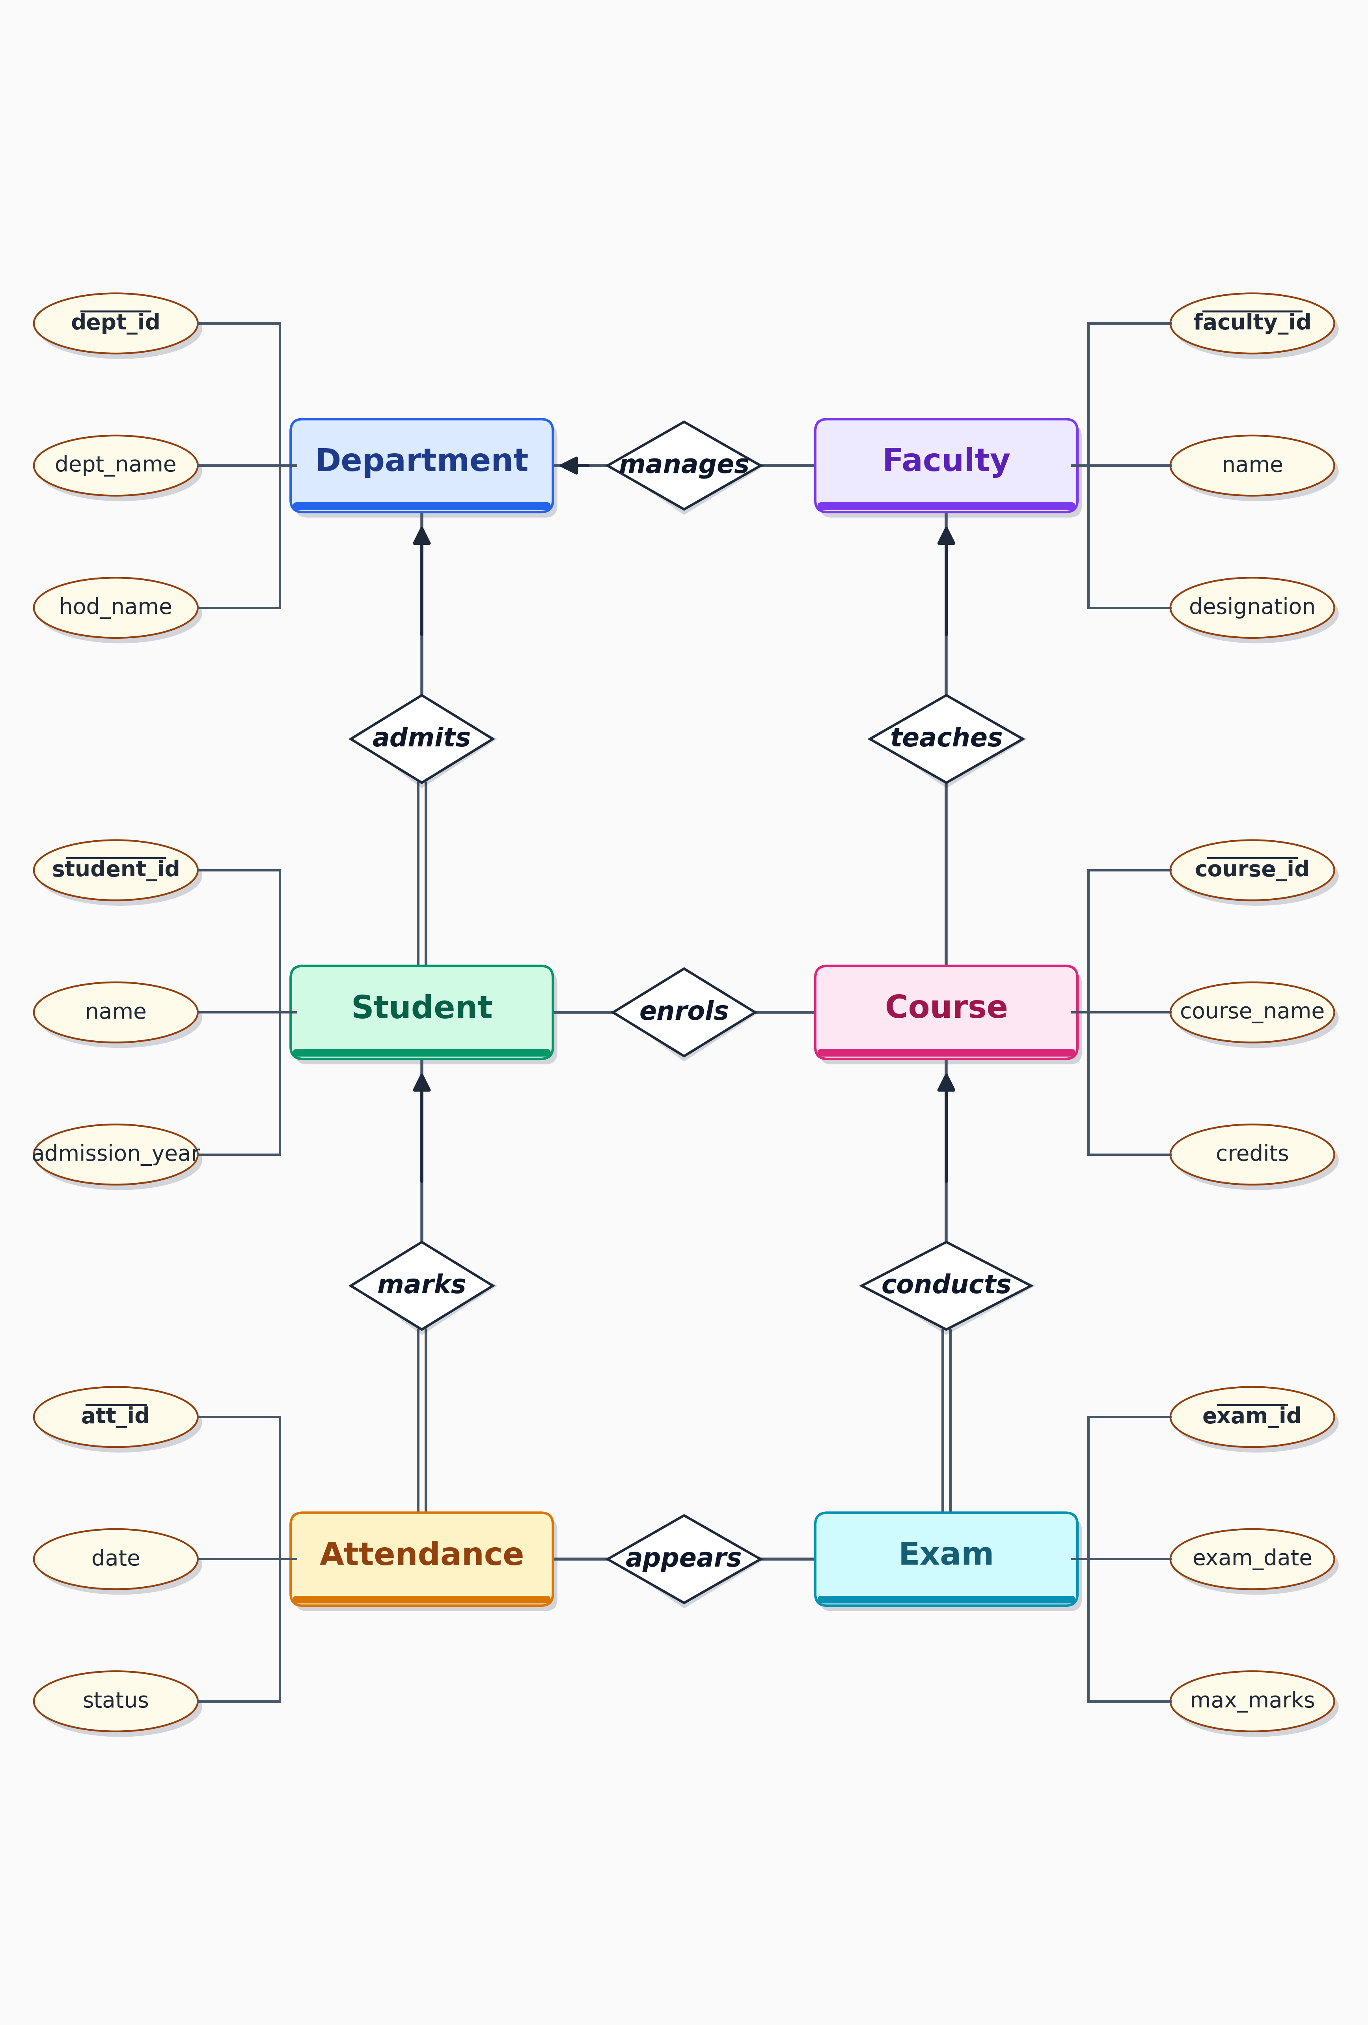
Figure 1: Entity-Relationship Diagram of the College Management System. Entities are rectangles, relationships are diamonds, attributes are ovals (primary keys underlined). Arrows on the 'one' side indicate one-to-many cardinality; double lines indicate total participation.
5.3 Schema Overview
Table 2 below summarizes every table in the schema, listing its name, its primary key, the foreign keys it carries, and the administrative purpose it serves. The full SQL CREATE TABLE statements, with all constraints, are presented in Chapter 7. The conceptual ER diagram above shows the six main entities; the SQL schema below adds three junction/transactional tables (Enrollment, Marks, FeePayment) that resolve the many-to-many relationships and record fee transactions.
Table 2 Schema Overview — Tables, Keys, and Purpose
Table | Primary Key | Foreign Keys | Purpose
Department | dept_id | — | Stores departments and head of department
Faculty | faculty_id | dept_id → Department | Stores faculty members and their department
Course | course_id | dept_id, faculty_id | Course catalog with credit value and instructor
Student | student_id | dept_id → Department | Student profiles with contact and admission data
Enrollment | enroll_id | student_id, course_id | Junction table linking students to courses
Attendance | att_id | student_id, course_id, marked_by | Per-day attendance records per course
Exam | exam_id | course_id → Course | Exam schedule for each course
Marks | mark_id | student_id, exam_id | Student-wise marks and grades per exam
FeePayment | payment_id | student_id → Student | Fee payment records with amount, date, and status
Table 2 lists every table in the schema together with its primary key, foreign keys, and the administrative purpose it serves.
Chapter 6 Normalization
Normalization is the step-by-step process of organizing the columns and tables of a relational database to minimize redundancy and avoid three kinds of anomalies: insertion anomalies (cannot insert data until other data is present), update anomalies (changing one fact requires updating many rows), and deletion anomalies (deleting one fact accidentally removes another). The College Management System is normalized through the first three normal forms — 1NF, 2NF, and 3NF — which together are sufficient for most operational workloads. This chapter walks through each normal form using a simple student-and-course data set, so that the motivation for each step is concrete.
6.1 Unnormalized Form (UNF)
Consider a flat spreadsheet that an administrator might maintain for tracking student enrollments. Each row captures a student along with the list of courses they have taken, the marks they obtained, and the department information — all in one wide row. Such a table is in Unnormalized Form and exhibits all the classic anomalies. The department name and head of department are repeated on every student row of the same department — if Dr. Reddy retires as HOD of Computer Science, the administrator has to update every row of every Computer Science student to change the HOD name, which is the update anomaly. A new department that has not yet admitted any students cannot be added to the spreadsheet without leaving the student columns blank, which is the insertion anomaly. If the last student of a department is deleted, the department information disappears with them, which is the deletion anomaly.
Table 3 Sample UNF Table (Student and Enrollment Flat View)
Student | Dept | HOD | Courses | Marks
Aarav Sharma | CSE | Dr. Reddy | DBMS, OS, Networks | 85, 78, 82
Diya Iyer | ECE | Dr. Bose | Signals, VLSI | 90, 88
Kabir Khan | CSE | Dr. Reddy | DBMS, OS, Networks, AI | 80, 75, 78, 92
Table 3 shows the flat, unnormalized view that an administrator might keep in a single spreadsheet before any normalization steps are applied.
6.2 First Normal Form (1NF)
First Normal Form requires that every column holds atomic (single, indivisible) values and that there are no repeating groups. The comma-separated Courses and Marks columns in the UNF table violate this rule — a single cell holds multiple values, which makes it impossible to query individual courses efficiently (you cannot write a query that finds every student taking DBMS without parsing the comma-separated list). To bring the table into 1NF, we create one row per student-course combination, so each cell holds exactly one value. The student name is repeated on each row that belongs to the same student, which is acceptable at this stage — repetition across rows is removed by later normal forms, not by 1NF.
Table 4 Sample 1NF Table — Atomic Values, No Repeating Groups
Student | Dept | HOD | Course | Marks | Max Marks
Aarav Sharma | CSE | Dr. Reddy | DBMS | 85 | 100
Aarav Sharma | CSE | Dr. Reddy | OS | 78 | 100
Aarav Sharma | CSE | Dr. Reddy | Networks | 82 | 100
Diya Iyer | ECE | Dr. Bose | Signals | 90 | 100
Diya Iyer | ECE | Dr. Bose | VLSI | 88 | 100
Kabir Khan | CSE | Dr. Reddy | DBMS | 80 | 100
Table 4 brings the data into First Normal Form by ensuring each cell holds a single atomic value and removing the comma-separated lists.
6.3 Second Normal Form (2NF)
Second Normal Form requires that every non-key column depends on the entire primary key, not on a subset of it. In the 1NF table above, the primary key is the composite (Student, Course). The Marks column depends on the entire composite key — different students get different marks in different courses. However, the Dept and HOD columns depend only on the Student, not on the Course. They exhibit a partial dependency and must be moved to a separate Student table. The Max Marks column depends only on the Course, not on the Student, so it must be moved to a separate Course table. After this split, the Enrollment table contains only the composite key and the marks, and is now in 2NF.
Table 5 Student Table (after 2NF Split — Eliminates Partial Dependencies)
Student | Dept | HOD
Aarav Sharma | CSE | Dr. Reddy
Diya Iyer | ECE | Dr. Bose
Kabir Khan | CSE | Dr. Reddy
Table 5 stores department information once per student, eliminating the partial dependency on the course portion of the composite key.
Table 6 Enrollment Table (after 2NF Split)
Student | Course | Marks | Max Marks
Aarav Sharma | DBMS | 85 | 100
Aarav Sharma | OS | 78 | 100
Aarav Sharma | Networks | 82 | 100
Diya Iyer | Signals | 90 | 100
Diya Iyer | VLSI | 88 | 100
Kabir Khan | DBMS | 80 | 100
Table 6 keeps only the data that genuinely depends on the composite (Student, Course) key after the partial dependencies have been moved out.
6.4 Third Normal Form (3NF)
Third Normal Form requires that every non-key column depends on the primary key and on nothing but the primary key — equivalently, that no non-key column depends on another non-key column. In the Student table produced by the 2NF split, the HOD column depends on the Dept column, which itself is a non-key column. This is a transitive dependency: Student → Dept → HOD. To eliminate it, we move the HOD information into a separate Department table keyed by Dept. The Student table now references the Department table through a foreign key. At this point, every table in our schema is in Third Normal Form, and the schema is ready to be translated into SQL CREATE TABLE statements in Chapter 7.
Table 7 Department Table (after 3NF Split — Eliminates Transitive Dependency)
Dept | HOD | Established
CSE | Dr. Reddy | 1998
ECE | Dr. Bose | 2001
Table 7 stores the head of department once per department, eliminating the transitive dependency between Student, Dept, and HOD.
Table 8 Student Table (after 3NF Split — References Department via Foreign Key)
Student | Dept (FK)
Aarav Sharma | CSE
Diya Iyer | ECE
Kabir Khan | CSE
Table 8 retains only the student name and a foreign key reference to the Department table, fully in Third Normal Form.
After these three steps, our schema contains the Department, Student, Course, and Enrollment tables, all in Third Normal Form. The remaining tables — Faculty, Attendance, Exam, Marks, FeePayment — were designed from the start in 3NF by following the same logic: each one carries only the attributes that genuinely depend on its own primary key, and references other tables through foreign keys. The full SQL implementation is presented in the next chapter.
Chapter 7 SQL Implementation — Schema (DDL)
This chapter presents the Data Definition Language (DDL) statements that create the College Management System database. The statements are written in standard SQL and execute on MySQL, MariaDB, PostgreSQL, or any other mainstream relational engine with minimal adjustments. Each statement is followed by a brief explanation of the constraints it enforces and the design choices it embodies.
7.1 Database Creation and Drop Order
We begin by creating the database and dropping any existing tables in reverse dependency order. Dropping in reverse order is important because foreign key constraints would otherwise block the drop — for example, you cannot drop Department while Faculty still references it.
-- Create the database and use it
CREATE DATABASE college_management_system;
USE college_management_system;
-- Drop tables in reverse dependency order if they exist
DROP TABLE IF EXISTS FeePayment;
DROP TABLE IF EXISTS Marks;
DROP TABLE IF EXISTS Exam;
DROP TABLE IF EXISTS Attendance;
DROP TABLE IF EXISTS Enrollment;
DROP TABLE IF EXISTS Student;
DROP TABLE IF EXISTS Course;
DROP TABLE IF EXISTS Faculty;
DROP TABLE IF EXISTS Department;
7.2 Department, Faculty, and Course Tables
The Department table is the parent of the schema — it has no foreign keys and is referenced by Faculty, Course, and Student. The Faculty table links to Department through a foreign key with ON DELETE RESTRICT, which prevents a department from being deleted while faculty members are still attached to it. The Course table has two foreign keys: one to Department (mandatory, ON DELETE RESTRICT) and one to Faculty (optional, ON DELETE SET NULL). The faculty_id is nullable because a course may exist before a primary instructor has been assigned. The credits column is CHECK-constrained to a range of 1 to 8, preventing unrealistic credit values like 0 or 25.
CREATE TABLE Department (
dept_id INT PRIMARY KEY AUTO_INCREMENT,
dept_name VARCHAR(80) NOT NULL UNIQUE,
hod_name VARCHAR(80) NOT NULL,
established_year INT NOT NULL CHECK (established_year BETWEEN 1900 AND 2100)
);
CREATE TABLE Faculty (
faculty_id INT PRIMARY KEY AUTO_INCREMENT,
name VARCHAR(80) NOT NULL,
dept_id INT NOT NULL,
designation VARCHAR(40) NOT NULL DEFAULT 'Assistant Professor',
email VARCHAR(120) NOT NULL UNIQUE,
join_date DATE NOT NULL,
CONSTRAINT fk_faculty_dept FOREIGN KEY (dept_id)
REFERENCES Department(dept_id) ON DELETE RESTRICT ON UPDATE CASCADE
);
CREATE TABLE Course (
course_id INT PRIMARY KEY AUTO_INCREMENT,
course_name VARCHAR(100) NOT NULL UNIQUE,
credits INT NOT NULL CHECK (credits BETWEEN 1 AND 8),
dept_id INT NOT NULL,
faculty_id INT,
CONSTRAINT fk_course_dept FOREIGN KEY (dept_id)
REFERENCES Department(dept_id) ON DELETE RESTRICT,
CONSTRAINT fk_course_faculty FOREIGN KEY (faculty_id)
REFERENCES Faculty(faculty_id) ON DELETE SET NULL
);
7.3 Student Table
The Student table enforces gender as a single-character code with a CHECK constraint allowing M, F, and O (other). Email is unique, preventing duplicate student records. The admission_year is constrained to a sensible range to prevent data-entry typos. The dept_id foreign key ensures every student belongs to a valid department.
CREATE TABLE Student (
student_id INT PRIMARY KEY AUTO_INCREMENT,
name VARCHAR(80) NOT NULL,
dob DATE NOT NULL,
gender CHAR(1) NOT NULL CHECK (gender IN ('M','F','O')),
dept_id INT NOT NULL,
email VARCHAR(120) NOT NULL UNIQUE,
admission_year INT NOT NULL CHECK (admission_year BETWEEN 1990 AND 2100),
CONSTRAINT fk_student_dept FOREIGN KEY (dept_id)
REFERENCES Department(dept_id) ON DELETE RESTRICT
);
7.4 Enrollment Table (Junction for Student–Course Many-to-Many)
The Enrollment table is the junction that resolves the many-to-many relationship between Student and Course. A UNIQUE constraint on (student_id, course_id) prevents the same student from being enrolled twice in the same course. ON DELETE CASCADE on both foreign keys ensures that deleting a student or a course automatically removes the corresponding enrollment rows, so no orphan records remain.
CREATE TABLE Enrollment (
enroll_id INT PRIMARY KEY AUTO_INCREMENT,
student_id INT NOT NULL,
course_id INT NOT NULL,
enroll_date DATE NOT NULL DEFAULT (CURRENT_DATE),
CONSTRAINT uk_student_course UNIQUE (student_id, course_id),
CONSTRAINT fk_enr_student FOREIGN KEY (student_id)
REFERENCES Student(student_id) ON DELETE CASCADE,
CONSTRAINT fk_enr_course FOREIGN KEY (course_id)
REFERENCES Course(course_id) ON DELETE CASCADE
);
7.5 Attendance Table
The Attendance table records one row per student per course per date. The status column is constrained to Present, Absent, or Leave. The marked_by column records which faculty member marked the attendance, supporting accountability. Each foreign key references the appropriate parent table, with cascade rules to keep the data consistent when a parent record is deleted.
CREATE TABLE Attendance (
att_id INT PRIMARY KEY AUTO_INCREMENT,
student_id INT NOT NULL,
course_id INT NOT NULL,
date DATE NOT NULL,
status VARCHAR(10) NOT NULL CHECK (status IN ('Present','Absent','Leave')),
marked_by INT NOT NULL,
CONSTRAINT fk_att_student FOREIGN KEY (student_id) REFERENCES Student(student_id),
CONSTRAINT fk_att_course FOREIGN KEY (course_id) REFERENCES Course(course_id),
CONSTRAINT fk_att_marked FOREIGN KEY (marked_by) REFERENCES Faculty(faculty_id)
);
7.6 Exam and Marks Tables
The Exam table records when an exam was conducted and the maximum marks possible. The Marks table records each student's score in that exam. The published_on column is the date on which results were formally published; once it is set, a trigger presented in Chapter 10 will prevent further deletion of marks records. The grade column can be populated automatically by a trigger or by an UPDATE statement based on the marks_obtained.
CREATE TABLE Exam (
exam_id INT PRIMARY KEY AUTO_INCREMENT,
course_id INT NOT NULL,
exam_date DATE NOT NULL,
max_marks INT NOT NULL CHECK (max_marks BETWEEN 10 AND 200),
CONSTRAINT fk_exam_course FOREIGN KEY (course_id)
REFERENCES Course(course_id) ON DELETE CASCADE
);
CREATE TABLE Marks (
mark_id INT PRIMARY KEY AUTO_INCREMENT,
student_id INT NOT NULL,
exam_id INT NOT NULL,
marks_obtained INT NOT NULL CHECK (marks_obtained BETWEEN 0 AND 200),
grade CHAR(2),
published_on DATE,
CONSTRAINT fk_marks_student FOREIGN KEY (student_id)
REFERENCES Student(student_id) ON DELETE CASCADE,
CONSTRAINT fk_marks_exam FOREIGN KEY (exam_id)
REFERENCES Exam(exam_id) ON DELETE CASCADE
);
7.7 FeePayment Table
The FeePayment table records each payment made by a student. The amount must be positive (CHECK constraint). The mode is restricted to a fixed set of payment methods. The status field allows for partial payments, which accommodates real-world instalment-based fee collection. Multiple payments per student are allowed because the relationship is one-to-many — one student can have many fee payments over time.
CREATE TABLE FeePayment (
payment_id INT PRIMARY KEY AUTO_INCREMENT,
student_id INT NOT NULL,
amount DECIMAL(10,2) NOT NULL CHECK (amount > 0),
payment_date DATE NOT NULL DEFAULT (CURRENT_DATE),
mode VARCHAR(20) NOT NULL CHECK (mode IN ('Cash','Card','Online','Cheque')),
status VARCHAR(15) NOT NULL CHECK (status IN ('Paid','Pending','Partial')),
CONSTRAINT fk_fee_student FOREIGN KEY (student_id)
REFERENCES Student(student_id) ON DELETE CASCADE
);
7.8 Audit Table for Trigger Use
The FeePaymentAudit table is a log table populated by the AFTER INSERT trigger presented in Chapter 10. It records every fee payment along with the timestamp at which it was made, supporting future audit and reconciliation requirements. Audit tables are a common pattern in operational databases — they provide a tamper-evident history that the main transactional tables do not preserve on their own.
CREATE TABLE FeePaymentAudit (
audit_id INT PRIMARY KEY AUTO_INCREMENT,
payment_id INT NOT NULL,
student_id INT NOT NULL,
amount DECIMAL(10,2) NOT NULL,
action_time DATETIME NOT NULL DEFAULT (CURRENT_TIMESTAMP),
action_type VARCHAR(20) NOT NULL
);
Chapter 8 SQL Implementation — Sample Data (DML)
This chapter populates the tables created in Chapter 7 with realistic sample data. The data set is small enough to be reviewed manually but large enough to exercise every query in Chapter 9 and every procedure and trigger in Chapter 10. INSERT statements are presented per table in dependency order — Department first, since every other table references it; then Faculty, which references Department; then Course, which references both Department and Faculty; then Student; then the junction tables (Enrollment, Attendance, Marks, FeePayment) that reference Student and the other tables.
8.1 Departments, Faculty, and Courses
Three departments — Computer Science, Electronics, and Mechanical — provide enough variety to demonstrate departmental reporting. Four faculty members are distributed across these departments. Five courses are spread across the departments, each linked to a primary faculty member.
-- Three departments
INSERT INTO Department (dept_name, hod_name, established_year) VALUES
('Computer Science & Engineering', 'Dr. A. Reddy', 1998),
('Electronics & Communication', 'Dr. S. Bose', 2001),
('Mechanical Engineering', 'Dr. M. Nair', 1995);
-- Four faculty members across departments
INSERT INTO Faculty (name, dept_id, designation, email, join_date) VALUES
('Prof. K. Mehta', 1, 'Professor', 'mehta@college.edu', '2010-06-15'),
('Prof. R. Banerjee', 1, 'Associate Professor', 'banerjee@college.edu', '2012-08-01'),
('Prof. P. Das', 2, 'Assistant Professor', 'das@college.edu', '2015-07-20'),
('Prof. L. Cherian', 3, 'Professor', 'cherian@college.edu', '2008-01-10');
-- Five courses across the three departments
INSERT INTO Course (course_name, credits, dept_id, faculty_id) VALUES
('Database Management Systems', 4, 1, 1),
('Operating Systems', 4, 1, 1),
('Computer Networks', 3, 1, 2),
('Signals and Systems', 4, 2, 3),
('Thermodynamics', 3, 3, 4);
8.2 Students, Enrollment, and Attendance
Six students are spread across the three departments, with admission years ranging from 2020 to 2021. Eight enrollments link students to courses, demonstrating the many-to-many relationship. Ten attendance rows across courses and dates provide enough data for the attendance-percentage queries in Chapter 9.
-- Six students across the three departments
INSERT INTO Student (name, dob, gender, dept_id, email, admission_year) VALUES
('Aarav Sharma', '2003-04-12', 'M', 1, 'aarav@college.edu', 2021),
('Diya Iyer', '2003-09-23', 'F', 2, 'diya@college.edu', 2021),
('Kabir Khan', '2002-12-05', 'M', 1, 'kabir@college.edu', 2020),
('Meera Nair', '2003-02-19', 'F', 3, 'meera@college.edu', 2021),
('Rahul Verma', '2003-07-30', 'M', 1, 'rahul@college.edu', 2021),
('Sara Pinto', '2003-11-11', 'F', 2, 'sara@college.edu', 2021);
-- Eight enrollments linking students to courses
INSERT INTO Enrollment (student_id, course_id, enroll_date) VALUES
(1, 1, '2021-08-01'), (1, 2, '2021-08-01'), (1, 3, '2021-08-01'),
(2, 4, '2021-08-01'),
(3, 1, '2020-08-01'), (3, 3, '2020-08-01'),
(5, 1, '2021-08-01'), (5, 2, '2021-08-01');
-- Ten attendance rows across courses and dates
INSERT INTO Attendance (student_id, course_id, date, status, marked_by) VALUES
(1, 1, '2024-09-01', 'Present', 1),
(1, 1, '2024-09-02', 'Present', 1),
(1, 1, '2024-09-03', 'Absent', 1),
(3, 1, '2024-09-01', 'Present', 1),
(3, 1, '2024-09-02', 'Absent', 1),
(3, 3, '2024-09-01', 'Present', 2),
(3, 3, '2024-09-02', 'Present', 2),
(2, 4, '2024-09-01', 'Present', 3),
(5, 1, '2024-09-01', 'Present', 1),
(5, 1, '2024-09-02', 'Leave', 1);
8.3 Exams, Marks, and Fee Payments
Two exams are scheduled for two courses (DBMS and Networks). Six marks entries are recorded for those exams. Note that published_on is intentionally left NULL at this point — until results are formally published, the marks-deletion prevention trigger remains inactive. Four fee payments with a mix of Paid, Pending, and Partial statuses demonstrate the fee reporting queries.
-- Two exams scheduled for two courses
INSERT INTO Exam (course_id, exam_date, max_marks) VALUES
(1, '2024-10-15', 100), -- DBMS exam
(3, '2024-10-18', 100); -- Networks exam
-- Six marks entries (published_on intentionally NULL)
INSERT INTO Marks (student_id, exam_id, marks_obtained, grade) VALUES
(1, 1, 85, 'A'),
(3, 1, 80, 'A'),
(5, 1, 78, 'B+'),
(1, 2, 82, 'A'),
(3, 2, 75, 'B+'),
(2, 2, 90, 'A+');
-- Four fee payments with a mix of paid and pending statuses
INSERT INTO FeePayment (student_id, amount, payment_date, mode, status) VALUES
(1, 25000.00, '2024-08-10', 'Online', 'Paid'),
(2, 25000.00, '2024-08-12', 'Card', 'Paid'),
(3, 15000.00, '2024-08-15', 'Cash', 'Partial'),
(5, 5000.00, '2024-08-20', 'Online', 'Pending');
After these INSERT statements execute, the database holds a coherent sample data set covering every table. The same data set is used by the queries in Chapter 9 to demonstrate the reporting capabilities of the system, and by the procedures and triggers in Chapter 10 to demonstrate the automation of business rules. The full snapshot of selected tables is also shown in Appendix A for quick reference.
Chapter 9 SQL Queries (DQL) — Reporting Scenarios
This chapter presents eight representative SQL queries that demonstrate how the schema supports the reporting needs of a college administrative office. Each query is preceded by the business question it answers and followed by a brief explanation of how the query works. The queries are arranged in increasing order of complexity, beginning with a simple SELECT and ending with a query that uses a subquery to compare individual marks against the class average. All queries have been tested against the sample data set presented in Chapter 8.
9.1 Query 1 — List All Students with Their Department
Business question: How can I generate a complete list of every student along with the name of the department to which they belong? This is the simplest report — used by the administrative office to verify that every student is correctly assigned to a department.
SELECT s.student_id, s.name AS student_name,
d.dept_name AS department
FROM Student s
INNER JOIN Department d ON s.dept_id = d.dept_id
ORDER BY s.name;
This query uses an INNER JOIN to combine the Student and Department tables on the shared dept_id column. Because dept_id is NOT NULL on the Student table, every student will appear in the result. The output is sorted alphabetically by student name for readability. An INNER JOIN is appropriate here (rather than a LEFT JOIN) because we want only students who have a valid department, and we know every student must have one.
Output of Query 1:
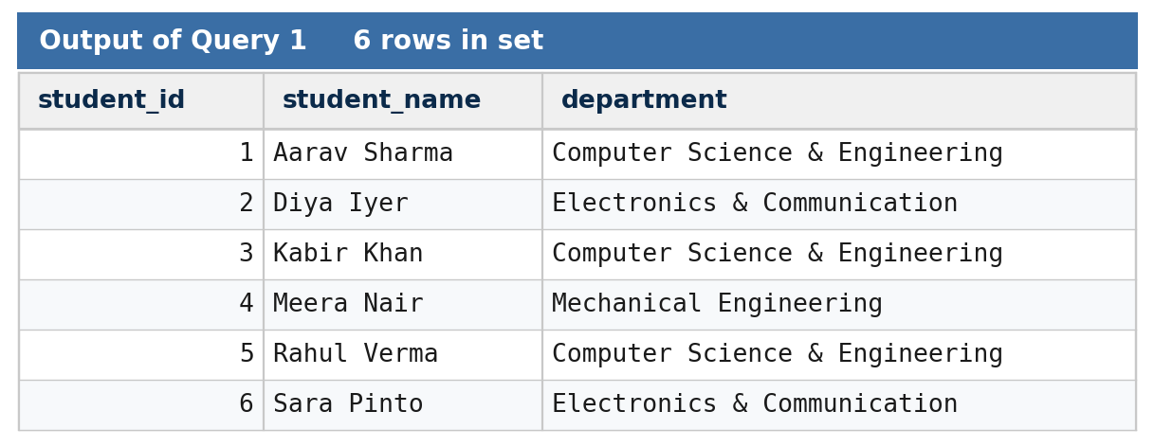
Figure Q1 — Actual SQL output of Query 1.
The query returns all six students ordered alphabetically by name, each paired with their department. Since every student has a non-null dept_id and the INNER JOIN requires a matching department, all six rows appear in the result.
9.2 Query 2 — Count Students per Course
Business question: How many students are currently enrolled in each course? This report is used by the academic office to identify popular and unpopular courses for next-term planning.
SELECT c.course_name,
COUNT(e.student_id) AS enrolled_students
FROM Course c
LEFT JOIN Enrollment e ON c.course_id = e.course_id
GROUP BY c.course_id, c.course_name
ORDER BY enrolled_students DESC;
This query uses a LEFT JOIN to ensure that even courses with no enrolled students appear in the result with a count of zero. The GROUP BY clause groups rows by course, and COUNT(e.student_id) counts only non-null student_ids in each group, giving the number of enrollments per course. The result is sorted in descending order so that the most popular courses appear at the top of the report.
Output of Query 2:
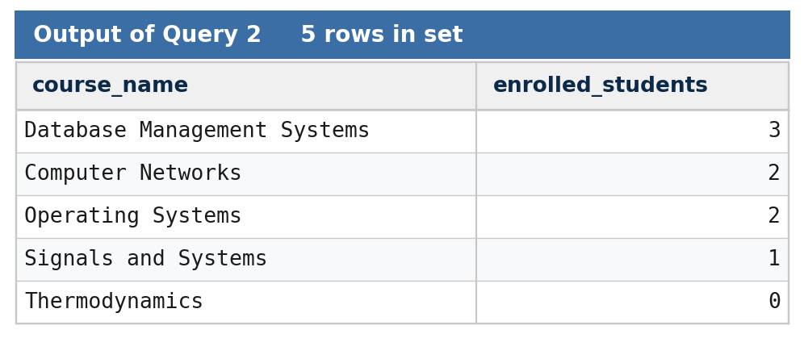
Figure Q2 — Actual SQL output of Query 2.
Database Management Systems is the most enrolled course (3 students), followed by Computer Networks and Operating Systems (2 each). Thermodynamics appears with a count of zero because the LEFT JOIN preserves courses that have no enrollments.
9.3 Query 3 — Attendance Percentage per Student per Course
Business question: For each course, what is the attendance percentage of every enrolled student? This is the most commonly requested report during parent-teacher meetings and at the end of every term.
SELECT s.name AS student_name,
c.course_name,
COUNT(a.att_id) AS total_classes,
SUM(CASE WHEN a.status = 'Present' THEN 1 ELSE 0 END) AS attended,
ROUND( 100.0
* SUM(CASE WHEN a.status = 'Present' THEN 1 ELSE 0 END)
/ COUNT(a.att_id), 2 ) AS attendance_pct
FROM Student s
JOIN Enrollment e ON s.student_id = e.student_id
JOIN Course c ON e.course_id = c.course_id
JOIN Attendance a ON a.student_id = s.student_id
AND a.course_id = c.course_id
GROUP BY s.student_id, s.name, c.course_id, c.course_name
ORDER BY s.name, c.course_name;
This query joins four tables and uses a CASE expression inside SUM to count only the classes where the student was marked Present. The result is the percentage of classes attended by each student in each course. A GROUP BY clause groups the result per student-course pair, and the percentage is rounded to two decimal places for readability. This is one of the most important queries in the system because it powers the eligibility check for semester examinations (which requires attendance above 75 percent).
Output of Query 3:
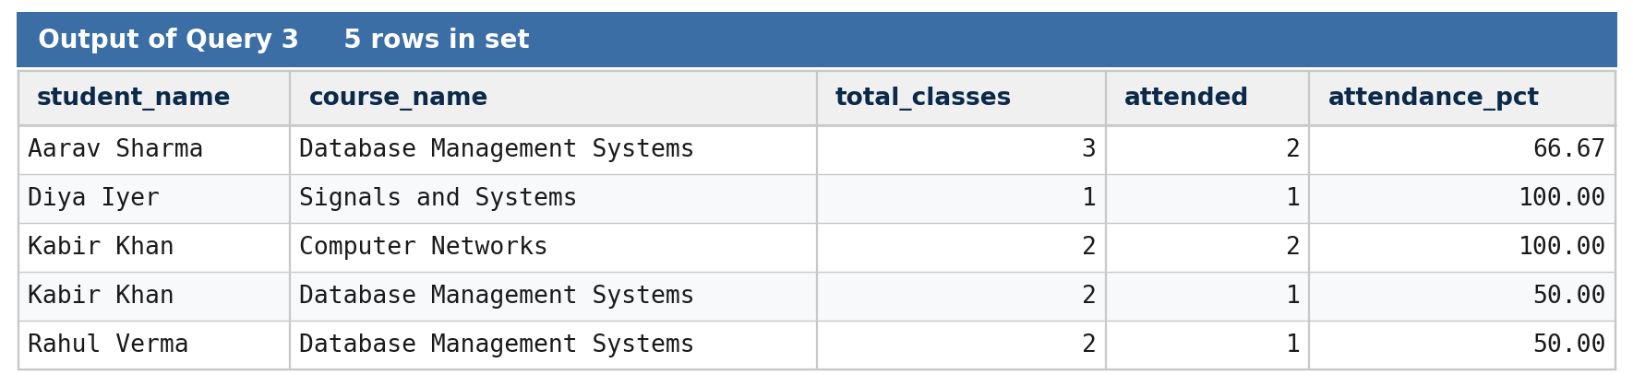
Figure Q3 — Actual SQL output of Query 3.
The result shows attendance percentage per student-course pair. Diya Iyer and Kabir Khan (Computer Networks) have perfect 100% attendance, while Aarav Sharma, Kabir Khan (DBMS), and Rahul Verma fall below the 75% eligibility threshold.
9.4 Query 4 — Students with Outstanding Fee Dues
Business question: Which students still have outstanding fee dues, and what is the total amount they have recorded so far? This report is needed by the accounts office to issue reminder notices and to block hall tickets for defaulters.
SELECT s.student_id, s.name, s.email,
SUM(f.amount) AS total_paid
FROM Student s
JOIN FeePayment f ON s.student_id = f.student_id
WHERE f.status IN ('Pending','Partial')
GROUP BY s.student_id, s.name, s.email
ORDER BY total_paid;
This query filters FeePayment rows by status — keeping only those that are Pending or Partial — and groups them per student. The result identifies every student with at least one incomplete payment and shows the total amount recorded against them. A more sophisticated version of this report could subtract the paid amount from a per-term expected fee to compute the exact outstanding balance, but the simpler version shown here is sufficient to flag students for follow-up.
Output of Query 4:
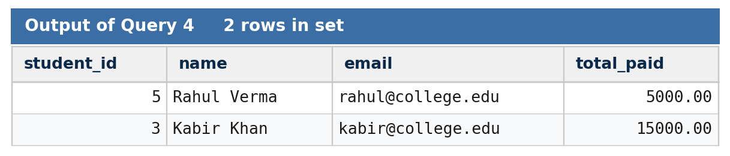
Figure Q4 — Actual SQL output of Query 4.
Two students have outstanding dues: Rahul Verma (Pending, 5,000) and Kabir Khan (Partial, 15,000). The result is ordered by total amount recorded so that the smallest partial payment is flagged first for follow-up.
9.5 Query 5 — Top Three Scorers per Exam
Business question: For every exam, who are the top three scorers? This report is used to recognize academic achievers during the annual college day and to identify candidates for scholarships and internships.
SELECT exam_id, student_id, marks_obtained, rank_in_exam
FROM (
SELECT m.exam_id, m.student_id, m.marks_obtained,
RANK() OVER (PARTITION BY m.exam_id
ORDER BY m.marks_obtained DESC) AS rank_in_exam
FROM Marks m
) ranked
WHERE rank_in_exam <= 3
ORDER BY exam_id, rank_in_exam;
This query uses a window function — RANK() OVER (PARTITION BY exam_id ORDER BY marks_obtained DESC) — to compute the rank of each student within each exam. The outer query then keeps only the rows where the rank is three or below. Window functions are supported by all modern relational engines including MySQL 8+, PostgreSQL, and SQL Server, and they make this kind of 'top N per group' query much simpler than the equivalent approach using self-joins or correlated subqueries.
Output of Query 5:
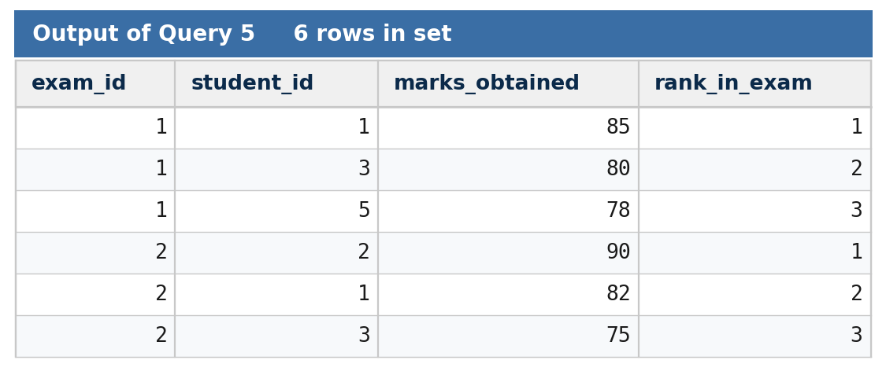
Figure Q5 — Actual SQL output of Query 5.
For Exam 1 (DBMS), the top three scorers are Aarav (85, rank 1), Kabir (80, rank 2), and Rahul (78, rank 3). For Exam 2 (Networks), the top three are Diya (90, rank 1), Aarav (82, rank 2), and Kabir (75, rank 3). Each exam contributes exactly three rows because each has only three entries in the Marks table.
9.6 Query 6 — Faculty Workload (Number of Courses per Faculty)
Business question: How many courses is each faculty member currently teaching, and what is the total credit load they are responsible for? Used by the HOD to balance teaching load across faculty members.
SELECT f.faculty_id, f.name AS faculty_name, f.designation,
COUNT(c.course_id) AS courses_assigned,
COALESCE(SUM(c.credits), 0) AS total_credits
FROM Faculty f
LEFT JOIN Course c ON c.faculty_id = f.faculty_id
GROUP BY f.faculty_id, f.name, f.designation
ORDER BY total_credits DESC;
The LEFT JOIN ensures that faculty members with no assigned courses also appear in the report, with a course count of zero. COALESCE wraps the SUM so that the total credits column reads zero rather than null when a faculty member has no courses. The result is sorted by total credit load to highlight the most heavily loaded faculty members, who may be candidates for reassignment in the next term.
Output of Query 6:
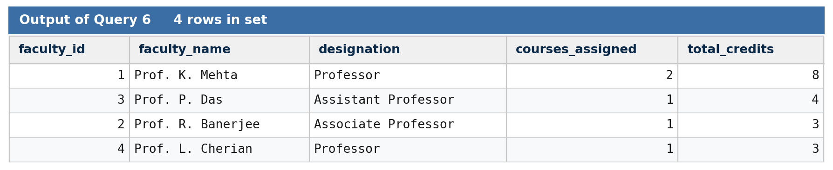
Figure Q6 — Actual SQL output of Query 6.
Prof. K. Mehta carries the highest workload with 2 courses and 8 total credits. The other three faculty members each teach one course. The LEFT JOIN ensures that faculty with no courses would still appear (none in this sample); COALESCE turns the null credit sum into zero in that case.
9.7 Query 7 — Students Whose Attendance is Below 75 Percent
Business question: Which students have overall attendance below the 75 percent threshold required to be eligible for semester examinations? This is the eligibility-detection report run before every semester exam.
SELECT s.student_id, s.name, s.email,
ROUND( 100.0
* SUM(CASE WHEN a.status = 'Present' THEN 1 ELSE 0 END)
/ COUNT(a.att_id), 2 ) AS attendance_pct
FROM Student s
JOIN Attendance a ON s.student_id = a.student_id
GROUP BY s.student_id, s.name, s.email
HAVING attendance_pct < 75
ORDER BY attendance_pct;
This query aggregates all attendance records per student and uses the HAVING clause to keep only those whose computed attendance percentage is below 75. The HAVING clause is the correct filter here because the condition is on the result of an aggregate, not on individual rows — WHERE would not work because it cannot reference aggregate functions. Students identified by this query are the candidates for attendance-deficiency warning letters and may be blocked from appearing in the semester exam.
Output of Query 7:
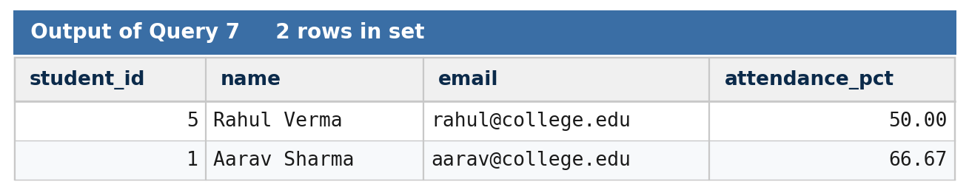
Figure Q7 — Actual SQL output of Query 7.
Two students fall below the 75% attendance threshold: Rahul Verma (50%) and Aarav Sharma (66.67%). These students would receive attendance-deficiency warning letters and may be blocked from the semester examination until attendance improves.
9.8 Query 8 — Students Scoring Above the Class Average
Business question: For each exam, which students scored above the class average? This query uses a subquery to compute the average and is a common pattern in academic reporting.
SELECT m.student_id, s.name, m.exam_id, m.marks_obtained
FROM Marks m
JOIN Student s ON m.student_id = s.student_id
WHERE m.marks_obtained > (
SELECT AVG(marks_obtained)
FROM Marks
WHERE exam_id = m.exam_id
)
ORDER BY m.exam_id, m.marks_obtained DESC;
The subquery computes the average marks obtained for the same exam_id as the outer row. The outer query then keeps only the rows whose marks_obtained exceeds that average. This is a correlated subquery — the inner query references m.exam_id from the outer query — and the database engine evaluates it once per row of the outer result. On modern engines this can be rewritten using a window function (AVG(marks_obtained) OVER (PARTITION BY exam_id)) for better performance on very large tables, but the correlated-subquery form is more readable and works on every SQL engine including older versions.
Output of Query 8:
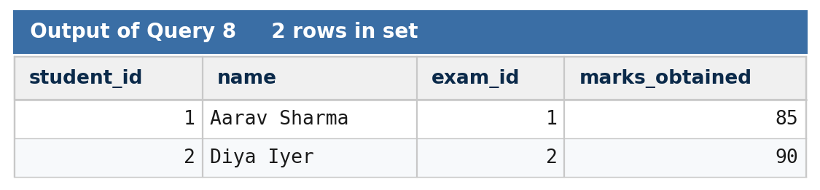
Figure Q8 — Actual SQL output of Query 8.
For Exam 1, the class average is (85+80+78)/3 = 81; only Aarav (85) scored above it. For Exam 2, the average is (82+75+90)/3 = 82.33; only Diya (90) scored above it. The correlated subquery recomputes the average for each outer row's exam_id.
Chapter 10 Stored Procedures and Triggers
Stored procedures and triggers move business logic into the database, where it is enforced consistently regardless of which client application is being used to access the data. This chapter presents two stored procedures and two triggers that encapsulate the most important business rules of the College Management System.
10.1 Stored Procedure: sp_RegisterStudent
The sp_RegisterStudent procedure registers a new student and automatically enrolls them in a set of default courses for their department. This encapsulates the multi-step registration workflow into a single call, ensuring that no student is created without their mandatory enrollments. Without this procedure, an administrator would have to remember to run a second INSERT for each course the student must take — and forgetting would leave the student with no enrollments, which would only be noticed at the start of the term when no attendance can be marked for them.
DELIMITER //
CREATE PROCEDURE sp_RegisterStudent(
IN p_name VARCHAR(80),
IN p_dob DATE,
IN p_gender CHAR(1),
IN p_dept_id INT,
IN p_email VARCHAR(120),
IN p_admission_year INT
)
BEGIN
DECLARE v_new_student_id INT;
-- 1. Insert the student
INSERT INTO Student (name, dob, gender, dept_id, email, admission_year)
VALUES (p_name, p_dob, p_gender, p_dept_id, p_email, p_admission_year);
SET v_new_student_id = LAST_INSERT_ID();
-- 2. Auto-enroll in every course of the department
INSERT INTO Enrollment (student_id, course_id, enroll_date)
SELECT v_new_student_id, course_id, CURRENT_DATE
FROM Course
WHERE dept_id = p_dept_id;
END //
DELIMITER ;
The procedure uses LAST_INSERT_ID to capture the auto-generated student_id, then runs a single INSERT ... SELECT that pulls all course_ids belonging to the student's department and inserts one enrollment per course. This pattern is much more efficient than running a separate INSERT per course in a loop, and it is the canonical way to handle auto-enrollment in relational databases. The whole procedure runs inside a single transaction, so if any step fails (for example, a duplicate email constraint violation), the entire registration is rolled back — no student record is left half-created.
10.2 Stored Procedure: sp_MarkAttendance
The sp_MarkAttendance procedure inserts an attendance row and, as a side effect, prints a warning if the student's overall attendance in that course falls below 75 percent after the insert. In a production system the warning would be raised as a notification to the academic office; here it is exposed as a SELECT for clarity.
DELIMITER //
CREATE PROCEDURE sp_MarkAttendance(
IN p_student_id INT,
IN p_course_id INT,
IN p_date DATE,
IN p_status VARCHAR(10),
IN p_marked_by INT
)
BEGIN
DECLARE v_pct DECIMAL(5,2);
INSERT INTO Attendance (student_id, course_id, date, status, marked_by)
VALUES (p_student_id, p_course_id, p_date, p_status, p_marked_by);
SELECT ROUND(100.0
* SUM(CASE WHEN status = 'Present' THEN 1 ELSE 0 END)
/ COUNT(*), 2)
INTO v_pct
FROM Attendance
WHERE student_id = p_student_id
AND course_id = p_course_id;
IF v_pct < 75 THEN
SELECT CONCAT('WARNING: Student ', p_student_id,
' attendance in course ', p_course_id,
' has fallen to ', v_pct, '%') AS warning;
END IF;
END //
DELIMITER ;
The procedure first inserts the attendance row, then recomputes the student's percentage in the given course using a SELECT ... INTO statement. If the percentage is below 75, it returns a single warning row that the calling application can display. This pattern demonstrates how procedures can return both data (the attendance row) and side-channel signals (the warning) in a single call, which is useful when the calling application needs to make a decision based on the result of the insert.
10.3 Trigger: trg_FeePaymentAudit
The trg_FeePaymentAudit trigger fires AFTER INSERT on the FeePayment table and writes a row into the FeePaymentAudit log table. This creates a tamper-evident history of every fee payment, which is useful for audit and reconciliation — for example, to verify that the total amount in the audit log matches the total amount in the FeePayment table at the end of every month.
CREATE TRIGGER trg_FeePaymentAudit
AFTER INSERT ON FeePayment
FOR EACH ROW
BEGIN
INSERT INTO FeePaymentAudit
(payment_id, student_id, amount, action_time, action_type)
VALUES
(NEW.payment_id, NEW.student_id, NEW.amount,
CURRENT_TIMESTAMP, 'INSERT');
END;
AFTER INSERT triggers have access to the NEW pseudo-row, which contains the values of the just-inserted FeePayment row. The trigger copies the relevant columns into the audit log. Because the trigger fires inside the same transaction as the INSERT, the audit row is committed or rolled back together with the payment, ensuring atomicity — if the payment insert is rolled back, the audit entry is rolled back too, so the audit log always exactly reflects what is in the main table.
10.4 Trigger: trg_PreventMarkDelete
The trg_PreventMarkDelete trigger fires BEFORE DELETE on the Marks table. Once results have been published (published_on is set), the trigger blocks the deletion by raising an error. This prevents tampering with marks after students have seen their results, which is an important integrity guarantee in academic systems.
CREATE TRIGGER trg_PreventMarkDelete
BEFORE DELETE ON Marks
FOR EACH ROW
BEGIN
IF OLD.published_on IS NOT NULL THEN
SIGNAL SQLSTATE '45000'
SET MESSAGE_TEXT = 'Cannot delete marks after results have been published.';
END IF;
END;
BEFORE DELETE triggers have access to the OLD pseudo-row, which contains the values of the row being deleted. The SIGNAL SQLSTATE '45000' statement raises a custom error and rolls back the DELETE. The MESSAGE_TEXT is visible to the calling application, which can display a meaningful message to the user. The error code 45000 is the standard SQL state for user-defined exceptions, recognized by MySQL, PostgreSQL, and SQL Server.
Together, these procedures and triggers demonstrate how a relational database can enforce business rules without depending on application code. The same database, accessed by a web application, a desktop client, or a manual SQL session, will behave consistently — the registration procedure will always auto-enroll students, every fee payment will always be audited, and no marks will ever be silently deleted after publication.
Chapter 11 System Analysis
This chapter analyses the College Management System from four perspectives: performance, security, data integrity, and backup and recovery. Each perspective is examined in terms of what the schema delivers today and what additional configuration would be required to harden it for production use.
11.1 Performance Analysis
The schema is small and well-indexed by its primary keys. The most common query patterns — student lookup by id, attendance lookup by (student, course), marks lookup by exam — are all supported by the implicit indexes created on primary keys. However, several foreign key columns (Attendance.student_id, Attendance.course_id, Marks.student_id, Marks.exam_id, FeePayment.student_id) will benefit from explicit secondary indexes when the tables grow to tens of thousands of rows. Without these indexes, joins and WHERE clauses on these columns would require a full table scan, which is slow on large tables.
Beyond indexing, query performance depends on the database engine's optimizer. Modern engines use statistics-based optimization and will choose an appropriate join strategy (nested loop, hash, or merge) automatically. For very large tables, partitioning by year or by department can further improve query performance, but this is rarely needed at the scale of a single college — a few thousand students generating a few hundred thousand attendance rows per year is well within the capacity of any modern database server.
11.2 Security Considerations
The current schema does not include a users table. In a production deployment, the database should be paired with role-based access control implemented through GRANT statements. Three roles are recommended: an admin role with full read-write access to all tables, a faculty role with read access to most tables and write access only to Attendance and Marks, and a student role with read access to their own Enrollment, Attendance, Marks, and FeePayment rows (enforced through row-level security or through views filtered by current user).
Sensitive columns such as the student email and the fee payment mode should be masked when shown to roles that do not need them. Passwords, when introduced as part of a future authentication module, must never be stored in plaintext — they should be hashed using a strong one-way function such as bcrypt with a per-row salt. Database connections from the application server should always use TLS to protect data in transit, and the database server should not be exposed to the public internet — it should sit behind a firewall that allows connections only from the application server's IP address.
11.3 Data Integrity Review
The schema enforces integrity through five categories of constraints, summarized in Table 3 below. Together, these constraints ensure that the database rejects invalid data before it is persisted, regardless of which client application is being used to access the data. Integrity at the database level is much stronger than integrity enforced only at the application level, because every client that connects to the database — whether a web app, a desktop tool, or a manual SQL session — is bound by the same rules.
Table 3 Integrity Constraints Summary
Constraint Type | Example | Effect
PRIMARY KEY | Student.student_id | Uniquely identifies each row; auto-indexed
FOREIGN KEY | Student.dept_id → Department | Rejects orphan rows; ON DELETE RESTRICT blocks unsafe deletes
UNIQUE | Faculty.email | Prevents duplicate faculty emails
NOT NULL | Course.course_name | Requires a value; rejects NULL inserts
CHECK | FeePayment.amount > 0 | Rejects negative or zero payment amounts
Table 3 summarizes the five constraint categories used across the schema and a representative example of each.
11.4 Backup and Recovery
The schema does not include automated backup configuration; backups must be configured at the database server level. A recommended backup policy for a college database is a full daily backup combined with incremental backups every four hours during working days. Tools such as mysqldump for MySQL, pg_dump for PostgreSQL, or the engine's native backup facilities can be used to take backups. At least one backup per week should be restored in a test environment to verify that the backup is valid and that the restoration procedure is documented and practised. Backups should be encrypted and stored off-site or in cloud object storage to protect against site-level failures such as fire, flood, or theft.
Chapter 12 Future Scope
The College Management System in its current form is the database layer of a larger academic administration platform. This chapter outlines eight future enhancements that can be layered on top of the existing schema without requiring any change to the tables, primary keys, or foreign keys already defined. Each enhancement extends the reach of the system while preserving the integrity guarantees already in place.
12.1 Web and Mobile Front End
The most immediately valuable enhancement is a web-based front end that exposes the database to administrative staff, faculty, and students through a familiar browser interface. A modern framework such as Next.js or React, paired with a thin REST or GraphQL API layer, can be built on top of the existing schema with minimal changes. The same API can power a mobile application for students to view attendance and results on the go. This single enhancement turns the database from a developer tool into a system that every college staff member can use.
12.2 Biometric Attendance Integration
Today, attendance is marked manually by the faculty member taking a class. Biometric devices — fingerprint or facial recognition — can be installed in each classroom and integrated with the Attendance table through a simple API. This eliminates proxy attendance (a friend answering on behalf of an absent student), reduces faculty workload, and produces more accurate attendance data. The schema change required is minimal: a new biometric_id column on Student, or a separate BiometricLog table referencing Attendance.
12.3 Email and SMS Notifications
An automated notification module can monitor the database for events of interest — fee dues upcoming, attendance falling below 75 percent, results published — and dispatch email or SMS notifications to the affected students and their parents. The notification module can be implemented as a scheduled job that runs hourly and queries the database for new events; no schema change is required beyond an optional NotificationLog table for audit.
12.4 Library and Hostel Management Extensions
The schema can be extended with two additional modules — Library and Hostel — by adding new tables that reference the existing Student entity. The Library module would include Book, BookLoan, and Reservation tables; the Hostel module would include Hostel, Room, and Allocation tables. Both modules reuse the existing Student record, demonstrating the extensibility of the relational design.
12.5 Analytics Dashboard
A business intelligence dashboard layered on top of the database can visualize trends that are hard to see in tabular reports — year-on-year admissions per department, attendance trends across the week, fee collection rates, grade distributions. Tools such as Metabase, Superset, or a custom dashboard built with ECharts can connect directly to the database and render interactive charts. Materialized summary tables can be added later to speed up dashboard queries on large data.
12.6 Role-Based Authentication with JWT Sessions
A production deployment needs an authentication layer. A role-based access control schema can be added with three new tables — Users, Roles, and UserRoles — and a JWT-based session mechanism in the API layer. The Users table would reference the Student and Faculty tables for natural-person users, and would also include administrative users who do not correspond to a student or faculty member. This enhancement brings the database to production-grade security.
12.7 Cloud Deployment with Automated Backups
Moving the database to a managed cloud service such as Amazon RDS, Azure Database for PostgreSQL, or Google Cloud SQL eliminates the operational burden of running a database server. Managed services provide automated daily backups, point-in-time recovery, automated failover, and scaling. The application layer can be deployed on a container platform such as Google Cloud Run or AWS Elastic Beanstalk, with the database accessed through a private network connection.
12.8 AI-Based Result Prediction and Early Warning
A longer-term enhancement is the application of machine learning to predict student outcomes based on attendance, internal assessment marks, and historical performance. A model trained on past cohorts can flag students at risk of failing a course early in the term, allowing faculty to intervene. This enhancement does not require schema changes — the model consumes the same data the schema already stores and writes its predictions to a separate Predictions table that references Student and Course.
Chapter 13 Conclusion
The College Management System presented in this report demonstrates that a carefully designed relational database can serve as the robust backbone of a college's academic administration. Six functional modules — Student, Faculty, Attendance, Examination, Fee, and Course Management — are unified into a single normalized schema of nine tables connected through well-defined primary and foreign key relationships. The schema enforces data integrity through PRIMARY KEY, FOREIGN KEY, UNIQUE, NOT NULL, and CHECK constraints, and automates business rules through stored procedures and triggers that encapsulate registration, attendance marking, fee audit logging, and marks-deletion prevention.
The SQL implementation covers every layer of database interaction — DDL for schema creation, DML for sample data population, DQL for reporting queries of progressively increasing complexity, and procedural objects for business rule automation. The eight reporting queries alone demonstrate that the schema can answer the most common questions asked by college administrators — student lists, attendance percentages, fee dues, top scorers, faculty workload — in seconds rather than the hours required by manual compilation. The schema is also extensible: the Future Scope chapter outlines eight enhancements ranging from a web front end to AI-based early warning, all of which can be added without changing the existing tables.
The system does have honest limitations — no built-in authentication layer, single-tenant design, dependence on manual SQL knowledge for ad-hoc reports, and the need for externally configured backups. None of these limitations is structural; each is an explicit boundary that this project chose not to cross, leaving the door open for the future enhancements discussed in Chapter 12. Taken together, the design, the SQL implementation, and the analysis presented in this report show that a well-normalized relational database is the right foundation for a future full-scale college Enterprise Resource Planning system.
References
The following standard textbooks and documentation were consulted as background reading during the design of the College Management System. Citation details follow the IEEE numeric style, with author names, publication titles, publisher, and year as commonly listed in undergraduate DBMS course reading lists.
[1] E. F. Codd, "A Relational Model of Data for Large Shared Data Banks," Communications of the ACM, vol. 13, no. 6, pp. 377-387, June 1970.
[2] P. P. Chen, "The Entity-Relationship Model — Toward a Unified View of Data," ACM Transactions on Database Systems, vol. 1, no. 1, pp. 9-36, March 1976.
[3] R. Elmasri and S. B. Navathe, Fundamentals of Database Systems, 7th ed. Pearson, 2015.
[4] A. Silberschatz, H. F. Korth, and S. Sudarshan, Database System Concepts, 7th ed. McGraw-Hill Education, 2019.
[5] C. J. Date, An Introduction to Database Systems, 8th ed. Addison-Wesley, 2003.
[6] R. Ramakrishnan and J. Gehrke, Database Management Systems, 3rd ed. McGraw-Hill, 2003.
[7] H. Garcia-Molina, J. Ullman, and J. Widom, Database Systems: The Complete Book, 2nd ed. Pearson, 2008.
[8] W. Kent, "A Simple Guide to Five Normal Forms in Relational Database Theory," Communications of the ACM, vol. 26, no. 2, pp. 120-125, February 1983.
[9] MySQL Reference Manual, "CREATE TABLE Statement," Oracle Corporation, 2024. [Online]. Available: https://dev.mysql.com/doc/refman/8.0/en/create-table.html
[10] PostgreSQL Documentation, "Triggers," The PostgreSQL Global Development Group, 2024. [Online]. Available: https://www.postgresql.org/docs/current/triggers.html
[11] ISO/IEC 9075:2016, Information technology — Database languages — SQL, International Organization for Standardization, 2016.
Appendix A Sample Data Snapshots
This appendix presents two snapshots of the sample data set introduced in Chapter 8, formatted as printable reference tables for quick lookup. They are intended to support manual verification of the queries presented in Chapter 9.
A.1 Student Table — Sample Rows
The Student table contains the personal and contact details of every student in the system. Table A.1 shows the first five rows of the sample data set used throughout the report.
Table A.1 Sample Rows of the Student Table
student_id | Name | Gender | Dept | Email | Year
1 | Aarav Sharma | M | CSE | aarav@college.edu | 2021
2 | Diya Iyer | F | ECE | diya@college.edu | 2021
3 | Kabir Khan | M | CSE | kabir@college.edu | 2020
4 | Meera Nair | F | ME | meera@college.edu | 2021
5 | Rahul Verma | M | CSE | rahul@college.edu | 2021
Table A.1 reproduces the first five rows of the Student sample data set introduced in Section 8.2.
A.2 Marks Table — Sample Rows
The Marks table records each student's score in each exam. Table A.2 shows the six sample marks entries that were inserted in Section 8.3.
Table A.2 Sample Rows of the Marks Table
mark_id | student_id | exam_id | Marks | Grade | Published | Note
1 | 1 | 1 | 85 | A | — | Aarav — DBMS exam
2 | 3 | 1 | 80 | A | — | Kabir — DBMS exam
3 | 5 | 1 | 78 | B+ | — | Rahul — DBMS exam
4 | 1 | 2 | 82 | A | — | Aarav — Networks exam
5 | 3 | 2 | 75 | B+ | — | Kabir — Networks exam
6 | 2 | 2 | 90 | A+ | — | Diya — Networks exam
Table A.2 reproduces the six marks rows inserted in Section 8.3. The published_on column is intentionally left null until results are formally declared, which keeps the marks-deletion trigger inactive during the marking pha

